Chapter test

Chapter 9 Reaction rates

Name:

Class:

Time permitted: 30 minutes

|  |  |  |  |  |
| --- | --- | --- | --- | --- |
|  | Section | Number of questions | Marks available | Marks achieved |
| A | Multiple choice | 15 | 15 |  |
| B | Short answer | 5 | 15 |  |
|  | Total |  | 30 |  |

Grade:

Scale:

|  |  |  |  |  |  |  |  |  |  |  |  |  |  |
| --- | --- | --- | --- | --- | --- | --- | --- | --- | --- | --- | --- | --- | --- |
| A+ | 29–30 | A | 26–28 | B | 23–25 | C | 19–22 | D | 15–18 | E | 9–14 | UG | 0–8 |

Comments:

Section A Multiple choice (15 marks)

Section A consists of 15 questions, each worth one mark. Each question has only one correct answer. Circle the correct answer. Attempt all questions. Marks will not be deducted for incorrect answers. You are advised to spend no more than 15 minutes on this section.

1 Why does reaction rate increase as temperature increases?

A Particles move faster and this increases the probability of collision.

B There are more particles at higher temperatures so more of them collide.

C The activation energy is lowered.

D Particles require a set temperature in which to begin colliding.

For questions 2 and 3 refer to the chemical reaction below.

CaCO3(s) + 2H+(aq)  Ca2+(aq) + CO2(g) + H2O(l)

2 Which does not occur during the reaction?

A The concentration of H2O increases.

B The mass of CaCO3 decreases.

C The volume of CO2 increases.

D The concentration of Ca2+ increases.

3 The rate of the reaction could not be determined by:

A recording the change in mass of the CaCO3 over time.

B recording the mass of CO2 lost over time.

C measuring the final mass of CaCO3.

D collecting and recording the volume of CO2 gas produced over time.

4 Which of the following graphs shows the fastest rate of formation of products?

A 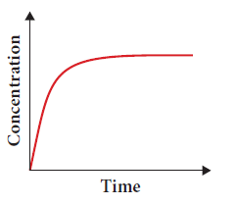 B 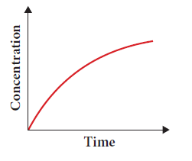

C 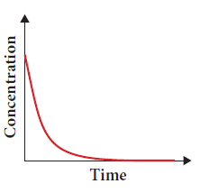 D 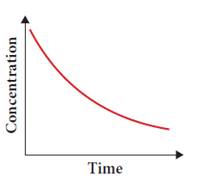

For question 5–7 refer to the graph below.

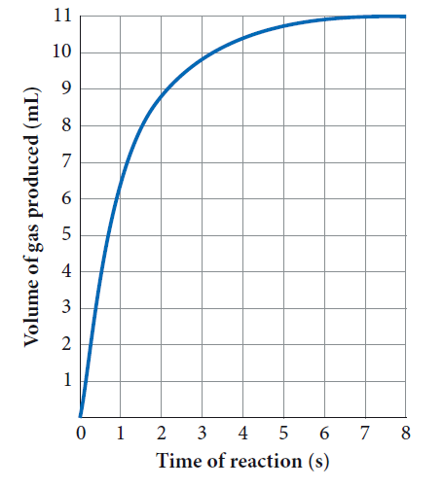

5 At which stage or stages was the reaction rate the fastest?

A 0 seconds

B 0–1 seconds

C 1–2 seconds

D 6–8 seconds

6 The reaction reached completion closest to:

A 0 seconds.

B 5 seconds.

C 6.5 seconds.

D 8 seconds.

7 The volume of gas produced at 2 time units is closest to:

A 0.5 mL.

B 6 mL.

C 8 mL.

D 9 mL.

8 Which of the following shows an unsuccessful collision?

A 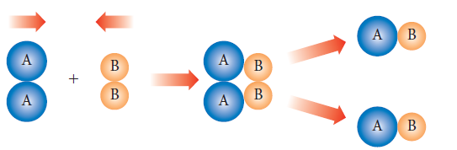

B 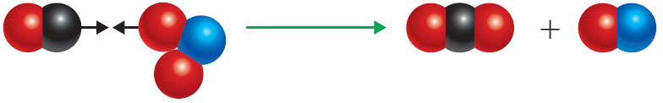

C 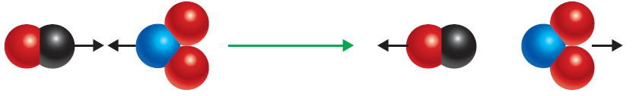

D 2H2 + O2  2H2O

9 Which diagram below represents the fastest reaction?

A 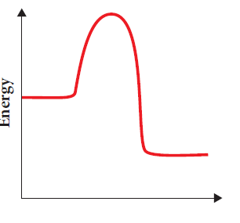 B 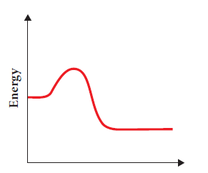

C 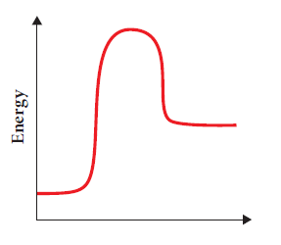 D 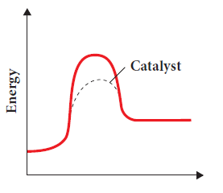

10 The rate of a reaction can be affected by:

A the number of successful collisions between particles.

B the amount of energy required to break bonds.

C the concentration of reactants.

D All of the above

11 Potassium permanganate is a purple solution that decolourises when it reacts with excess oxalic acid according to the equation:



Which of the following is true?

A When production of carbon dioxide bubbles ceases, there are no reactants left.

B The faster the bubbles are given off, the slower the rate of reaction.

C The lighter the colour of the solution, the greater the rate of reaction.

D The lighter the colour of the solution, the lower the concentration of the reactants.

12 With reference to this graph, which statement is false?

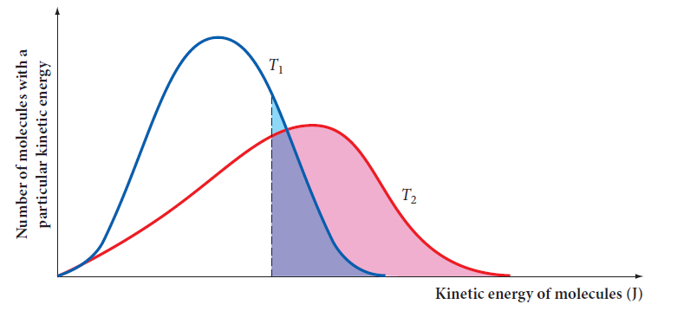

A The total number of particles under the curve in T1 = T2.

B The total number of particles under the curve in T1 > T2.

C Particles have a higher average speed at T2.

D There are more molecules with enough energy for successful collisions in T2.

For questions 13–15 refer to the diagram below.

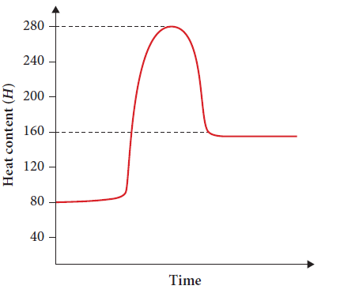

13 The heat content of the reactants is closest to:

A 80 kJ.

B 160 kJ.

C 200 kJ.

D 280 kJ.

14 ΔH is equal to:

A –200 kJ.

B +200 kJ.

C –80 kJ.

D +80 kJ.

15 The activation energy is equal to:

A 80 kJ.

B 160 kJ.

C 200 kJ.

D 280 kJ.

Section B Short answer (15 marks)

Section B consists of five questions. Write your answers in the spaces provided. You are advised to spend 20 minutes on this section.

1 Draw a labelled energy profile diagram to help describe what occurs during an endothermic reaction. (3 marks)

2 a Define activation energy. (1 mark)

b Describe a way in which the rate of reaction can be affected by altering the activation energy of a reaction. (2 marks)

3 Describe three ways in which the rate of reaction can be increased in a chemical reaction. (3 marks)

4 A student makes two cups of tea and adds some sugar to each, allowing it to dissolve for 30 seconds. One cup has a teaspoon of sugar grains added while the other has a sugar cube added. (Assume the teaspoon of sugar and the sugar cube contain the same amount of sugar.)

a Identify which cup of tea would be sweeter after 30 seconds. Justify your answer. (1 mark)

b Describe two more things you could do to increase the rate the sugar dissolves in the tea. (2 marks)

5 Draw suitable particle diagrams for the following chemical reaction to help explain the collision theory model.

Mg(s) + 2HCl(aq)  MgCl2(aq) + H2(g)

(3 marks)

End of test (30 marks)